Chapter 9, Solution 24.

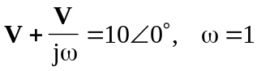
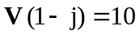
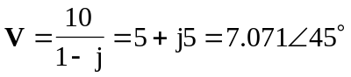
Therefore,
v(t) = 7.071cos(t + 45) V

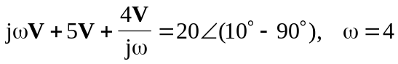
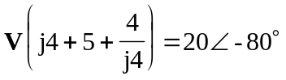
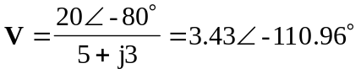
Therefore,
v(t) = 3.43cos(4t – 110.96) V

